Q-1. Write an SQL query to fetch “FIRST_NAME” from Worker table using the alias name as <WORKER_NAME>.

select first_name from Worker as WORKER_NAME

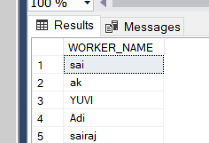

#### Q-2. Write an SQL query to fetch unique values of DEPARTMENT from Worker table.

#### select distinct Department from Worker

#### 

#### Q-3. Write an SQL query to show the last 5 record from a table.

#### select top 5 * from Worker order by customer_idDesc